Creating a Private Bucket on Amazon S3
This process explains how to create a bucket in Amazon S3 with restricted access. The bucket is kept private by enabling “Block all public access,” ensuring that only authorized users can view or manage the files stored in it.

Step 1: Dashboard
Open your private bucket in Amazon S3 to access its dashboard, where you can manage files, view details, and control permissions while keeping access restricted.
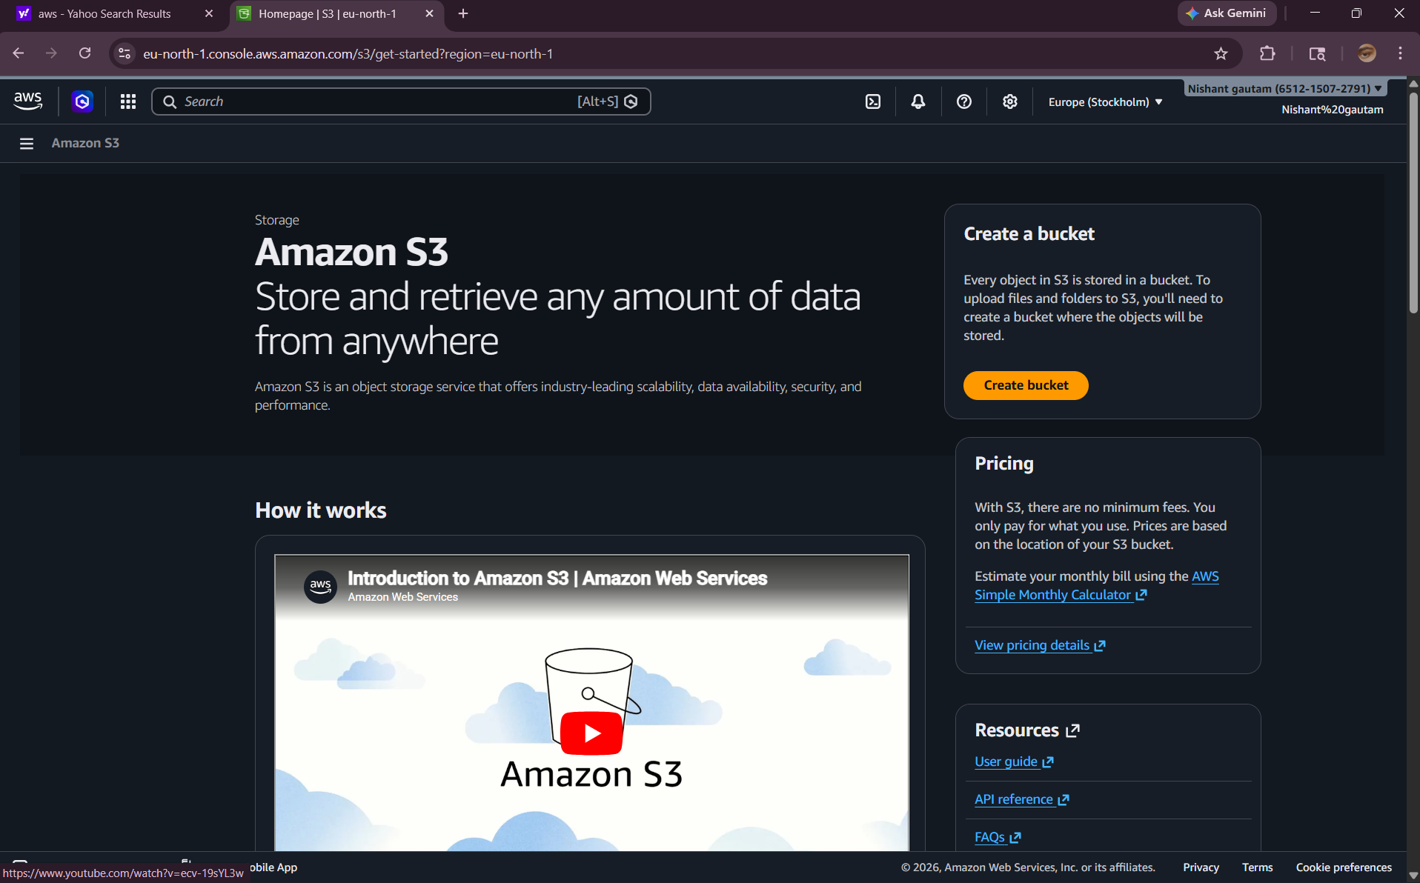

Step 2: Creating a Bucket
In Amazon S3, click on “Create bucket,” enter a unique name, select a region, and keep “Block all public access” enabled. Then click “Create bucket” to create a private bucket.
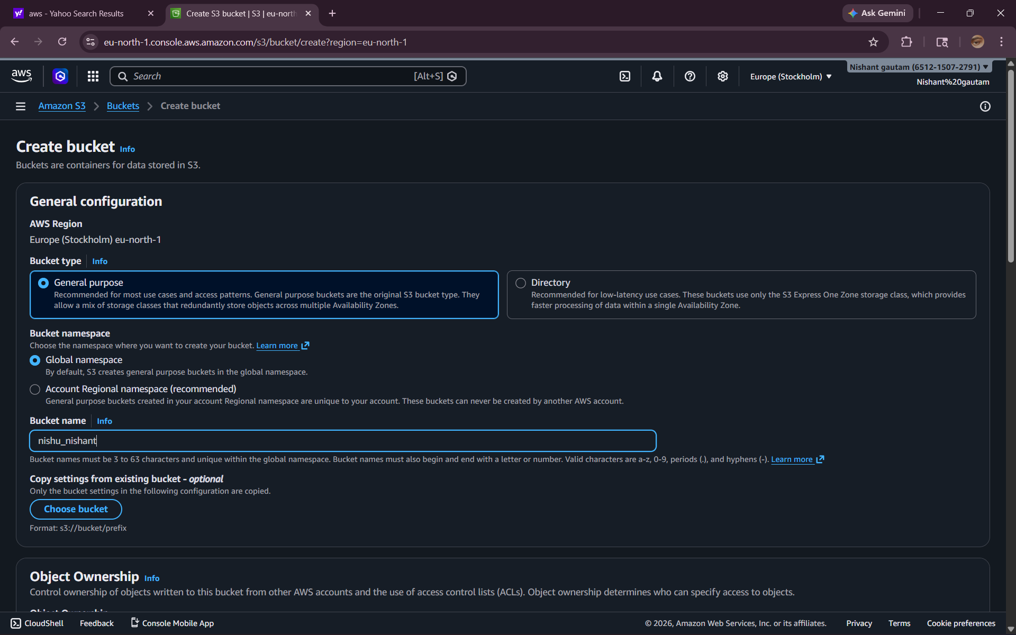
Step 3 : Encryption Settings
In Amazon S3, enable default encryption for the bucket to protect your data. You can choose options like server-side encryption to ensure files are securely stored.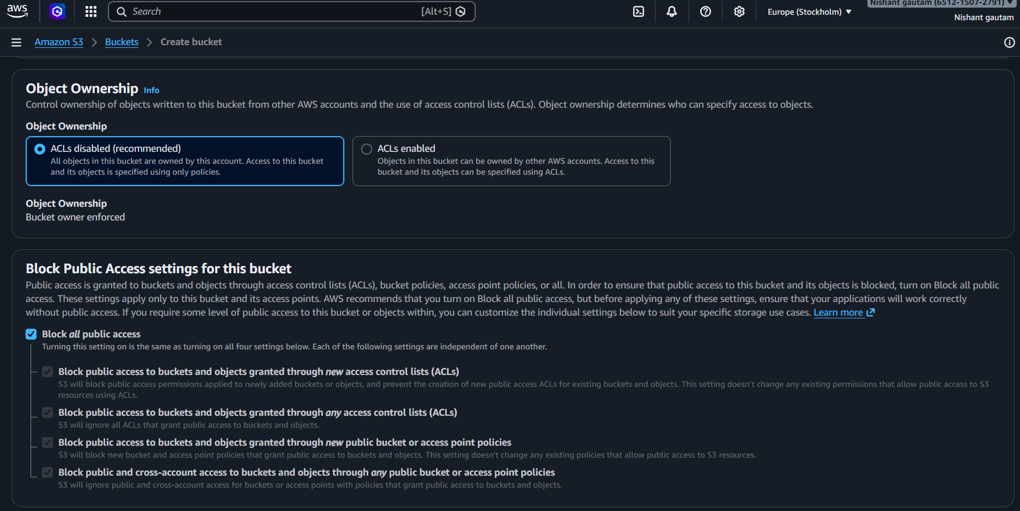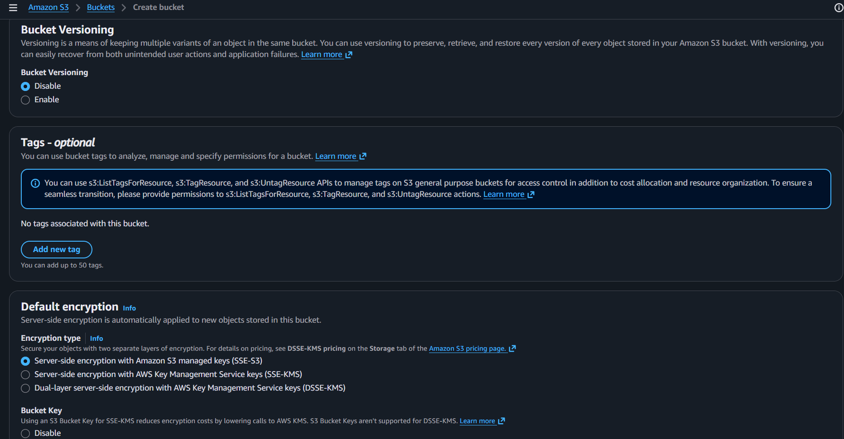
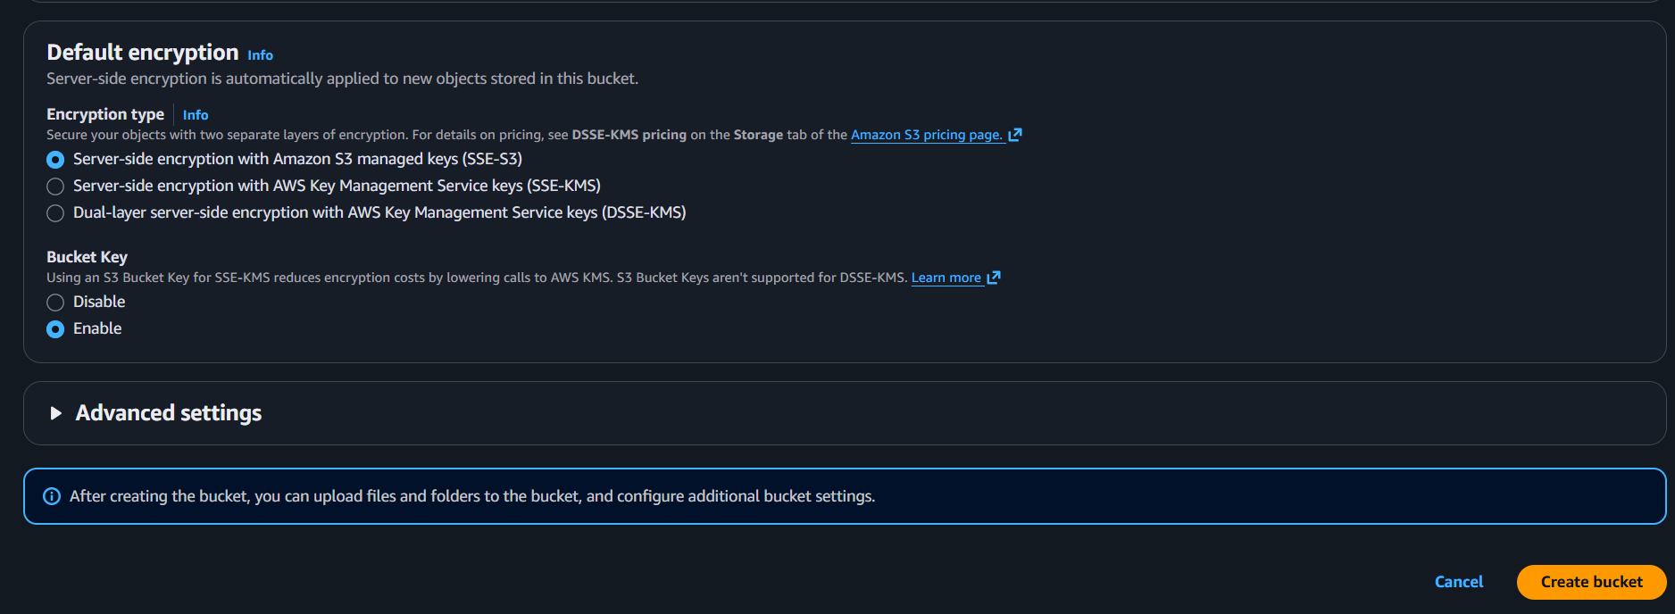
Step 4 : The Bucket’s dashboard
Open your private bucket in Amazon S3 to view its dashboard, where you can manage objects, check properties, and control access securely.
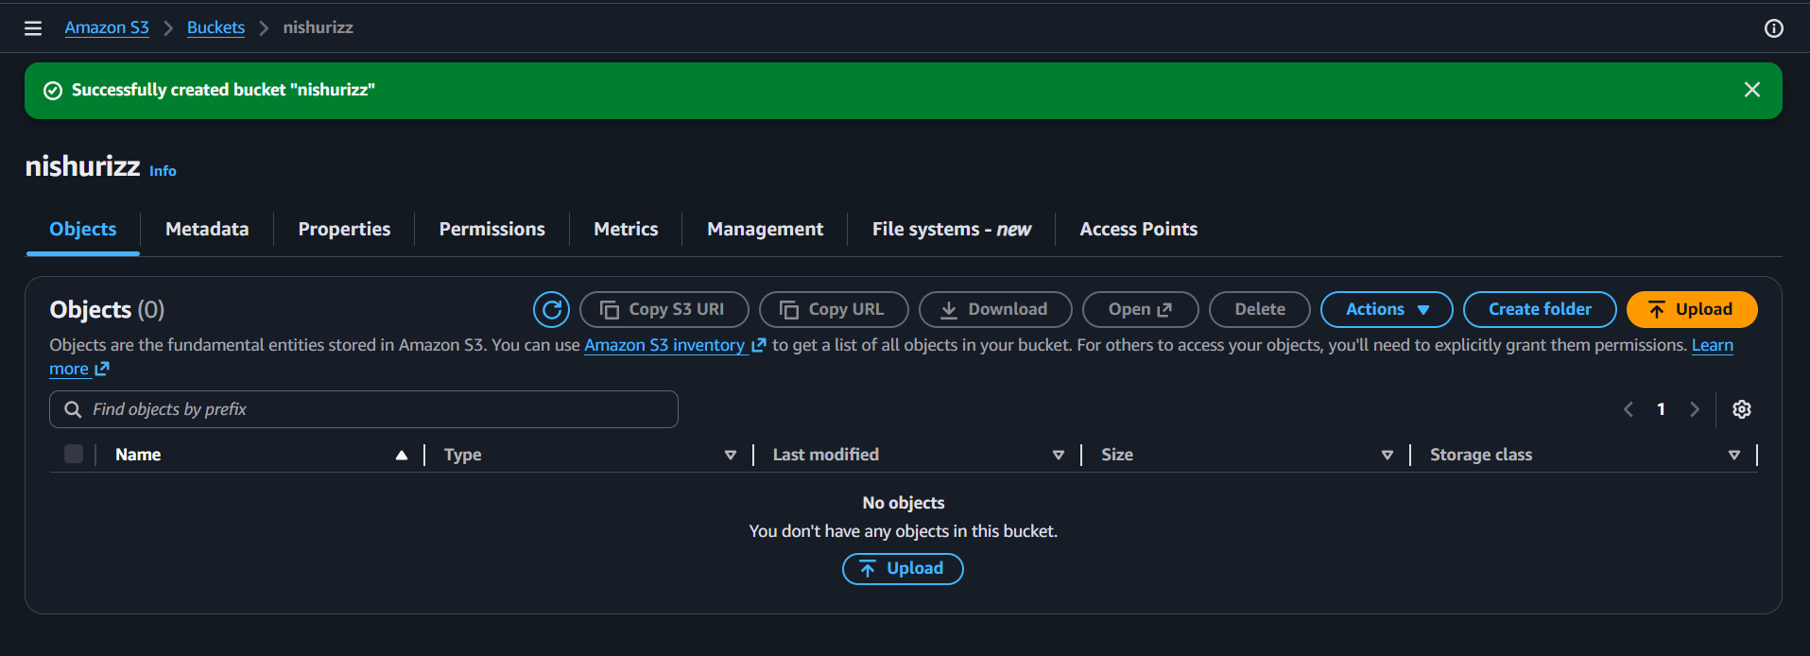
Step 5 : Uploading Files
In your private bucket in Amazon S3, click on “Upload,” select the files from your system, and upload them securely to the bucket.
